LAB 2- Jira
Problems statement 18- Clinical Trial Subject Recruitment Engine

Name:Deeptha S
SRN:PES1UG24CS144
SECTION:’C’

Epic 1: Candidate Pre-Screening & Eligibility
Story 1.1: Submit Pre-Screening Questionnaire
As a trial candidate,
I want to select a trial and fill in its pre-screening questionnaire,
So that I can find out whether I qualify without visiting the site.
Priority: High Points: 5
Story 1.2: Validate Required Answers
As a trial candidate,
I want the system to highlight any required questions I have left blank before submission,
So that my form is not rejected or scored on incomplete information.
Priority: Medium Points: 2
Story 1.3: Automated Eligibility Decision
As a trial candidate,
I want my answers checked automatically against the trial's inclusion and exclusion criteria,
So that I get an Eligible or Not Eligible result immediately.
Priority: High Points: 8
Story 1.4: View Failed Criteria
As a trial candidate,
I want to see which specific criteria I did not meet when I am marked Not Eligible,
So that I understand the decision and can consider other trials.
Priority: Medium Points: 3
Story 1.5: Fast Result Under Load
As a trial candidate,
I want my eligibility result returned within 3 seconds even when many candidates are screening at once,
So that I am not left waiting and do not abandon the application.
Priority: High Points: 5

Epic 2: Trial Criteria Management
Story 2.1: Define Trial Criteria
As a clinical researcher,
I want to add inclusion and exclusion criteria to a trial,
So that candidate screening runs against my study protocol.
Priority: High Points: 5
Story 2.2: Edit Trial Criteria
As a clinical researcher,
I want to edit a trial's criteria and have the changes applied from the very next screening,
So that recruitment always reflects the current protocol version.
Priority: High with Points: 3

Epic 3: Informed Consent Management
Story 3.1: View Informed Consent Form
As an eligible candidate,
I want to read the informed consent form for the trial,
So that I understand the risks and commitments before agreeing.
Priority: High oints: 3
Story 3.2: Sign Consent Electronically
As an eligible candidate,
I want to sign the consent form electronically,
So that I can join the trial without paperwork delays.
Priority: High Points: 8
Story 3.3: Block Enrolment Without Consent
As a clinical researcher,
I want the system to prevent enrolment until a signed consent record with form version and timestamp exists,
So that no subject joins the trial in breach of regulation.
Priority: High Points: 5

Epic 4: Study Visit Scheduling & Compliance
Story 4.1: Book a Study Visit
As a consented subject,
I want to book my study visits from the available slots,
So that I can fit trial appointments around my schedule.
Priority: Medium Points: 5
Story 4.2: Receive Visit Reminder
As a consented subject,
I want an automated reminder before each booked visit,
So that I do not miss an appointment.
Priority: Medium Points: 3
Story 4.3: Record Visit Attendance
As a clinical researcher,
I want to mark each visit as Attended or Missed,
So that protocol deviations are captured accurately.
Priority: Medium Points: 3
Story 4.4: View Visit Compliance Log
As a clinical researcher,
I want to view the visit compliance log for a subject,
So that I can spot repeated missed visits and act on them.
Priority: Low Points: 2

Epic 5: Recruitment Reporting & Regulatory Audit
Story 5.1: View Recruitment Report
As a clinical researcher,
I want a report showing how many candidates were screened, found eligible, consented and enrolled,
So that I can track progress against the enrolment target.
Priority: Medium Points: 5
Story 5.2: Auditor Access to Reports
As a compliance auditor,
I want read-only access to the recruitment report for a selected trial,
So that I can monitor the study without altering any records.
Priority: Mediu Points: 3
Story 5.3: Automatic Audit Trail Entries
As a compliance auditor,
I want every change to a candidate, eligibility or consent record logged with user, timestamp, old value and new value,
So that the study meets 21 CFR Part 11 requirements.
Priority: High points: 8
Story 5.4: Immutable Audit Records
As a compliance auditor,
I want stored audit entries to be impossible to edit or delete,
So that regulators can trust the record has not been tampered with.
Priority: High Points: 5

Jira backlog with Epics and User Stories

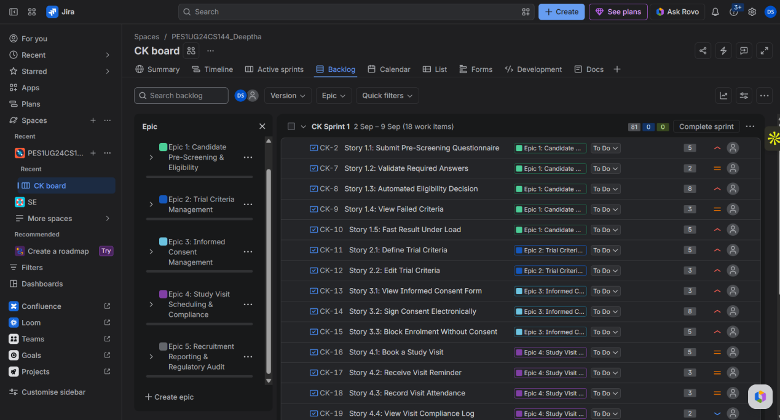’

Story point Assignments

Epic | User Story | Priority | Points | Hours | Justification
Epic 1 | 1.1 Submit Pre-Screening Questionnaire | High | 5 | 10 | Dynamic form rendering plus answer persistence
Epic 1 | 1.2 Validate Required Answers | Medium | 2 | 4 | Client-side validation on an existing form
Epic 1 | 1.3 Automated Eligibility Decision | High | 8 | 16 | Core rule engine, highest logical complexity
Epic 1 | 1.4 View Failed Criteria | Medium | 3 | 6 | Reesult screen built on data the engine already returns
Epic 1 | 1.5 Fast Result Under Load | High | 5 | 10 | Query tuning and a 200-user load test
Epic 2 | 2.1 Define Trial Criteria | High | 5 | 10 | New CRUD screens with criteria data model
Epic 2 | 2.2 Edit Trial Criteria | High | 3 | 6 | Reuses 2.1 screens, adds versioning on save
Epic 3 | 3.1 View Informed Consent Form | High | 3 | 6 | Versioned document display, little logic
Epic 3 | 3.2 Sign Consent Electronically | High | 8 | 16 | Signature capture plus regulated storage, high uncertainty
Epic 3 | 3.3 Block Enrolment Without Consent | High | 5 | 10 | Guard condition across the enrolment workflow
Epic 4 | 4.1 Book a Study Visit | Medium | 5 | 10 | Slot availability and booking conflicts
Epic 4 | 4.2 Receive Visit Reminder | Medium | 3 | 6 | Scheduled job through the Notification Service
Epic 4 | 4.3 Record Visit Attendance | Medium | 3 | 6 | Simple status update by the researcher
Epic 4 | 4.4 View Visit Compliance Log | Low | 2 | 4 | Read-only list over existing visit data
Epic 5 | 5.1 View Recruitment Report | Medium | 5 | 10 | Aggregation queries across four funnel stages
Epic 5 | 5.2 Auditor Access to Reports | Medium | 3 | 6 | Role-based read-only permission on 5.1
Epic 5 | 5.3 Automatic Audit Trail Entries | High | 8 | 16 | Cross-cutting interceptor on every write path
Epic 5 | 5.4 Immutable Audit Records | High | 5 | 10 | Append-only storage and permission hardening

Epic | Stories | Points | Sprint
Epic 1: Candidate Pre-Screeening & Eligibility | 5 | 23 | Sprint 1
Epic 2: Trial Criteria Management | 2 | 8 | Sprint 1
Epic 3: Informed Consent Management | 3 | 16 | Sprint 1
Epic 4: Study Viisit Scheduling & Compliance | 4 | 13 | Sprint 2
Epic 5: Recruitment Reporting & Regulatory Audit | 4 | 21 | Sprint 2

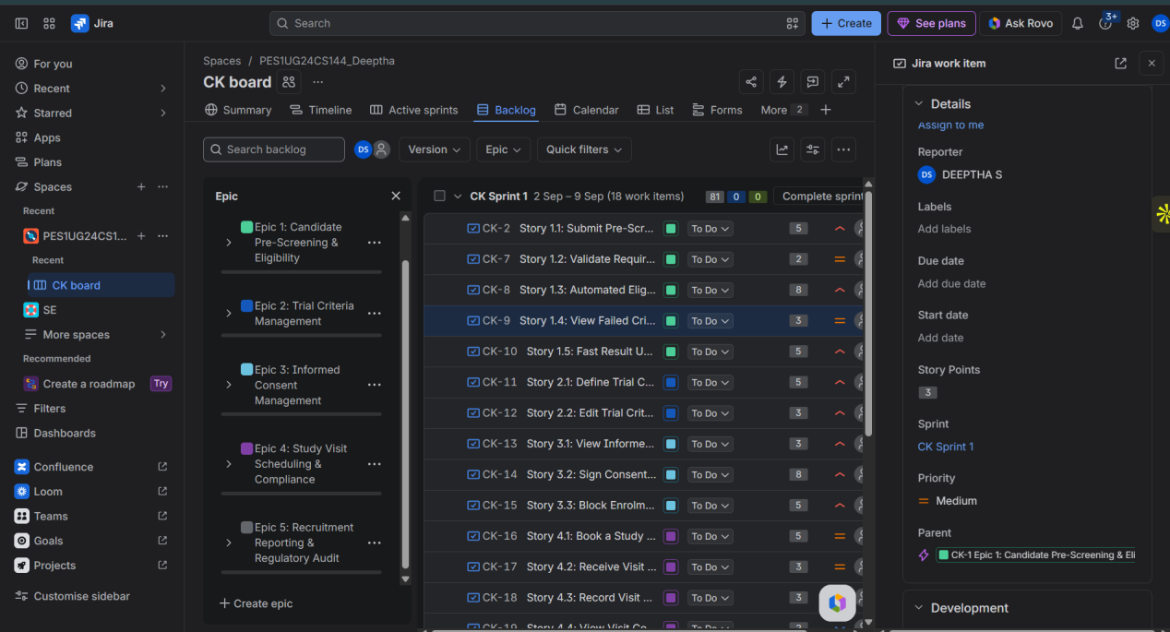

Sprint Board/ Active sprint view

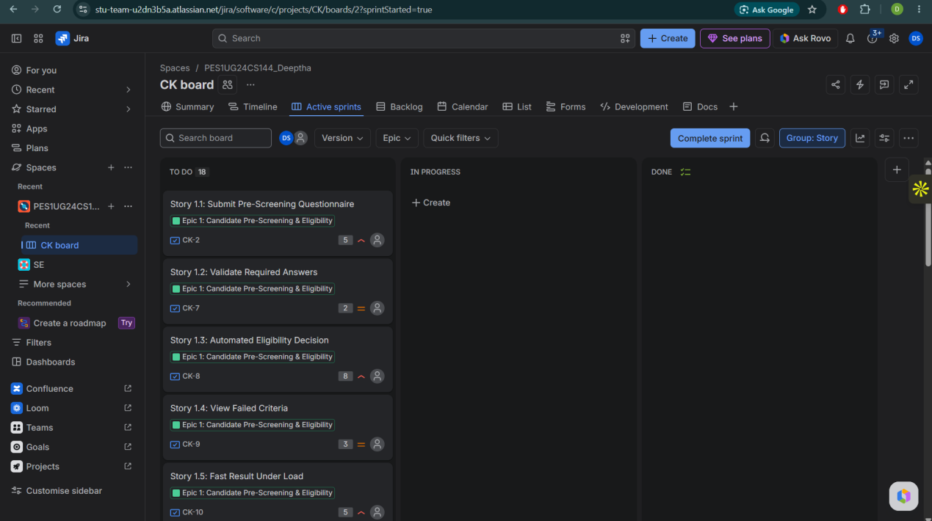

Sprint 1 wth Epics 1,2 and 3

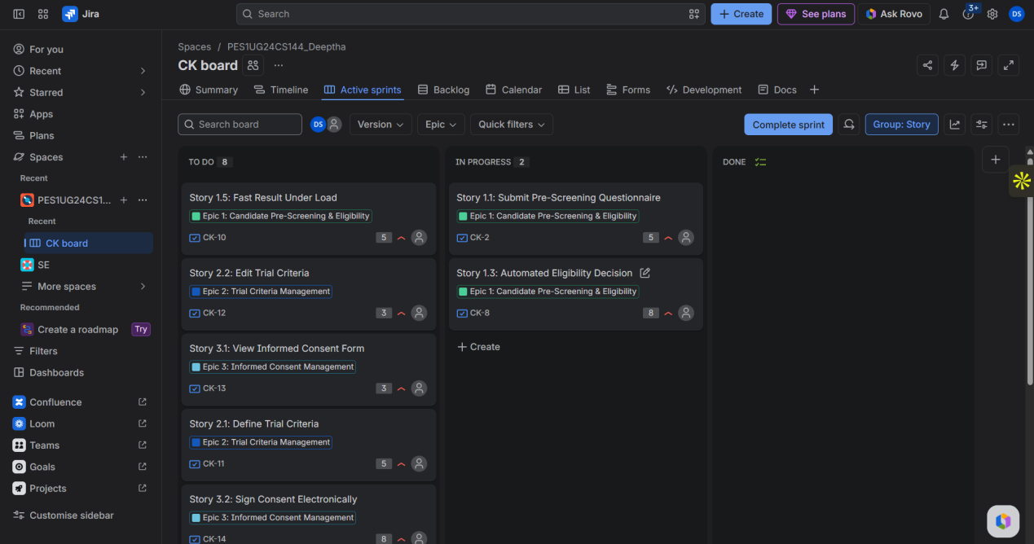
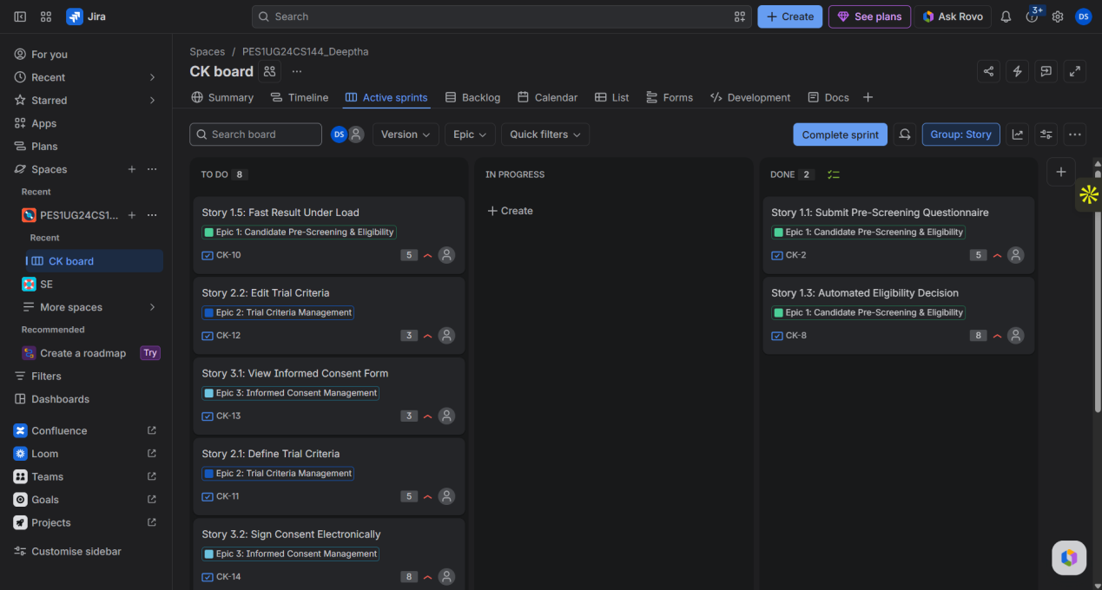
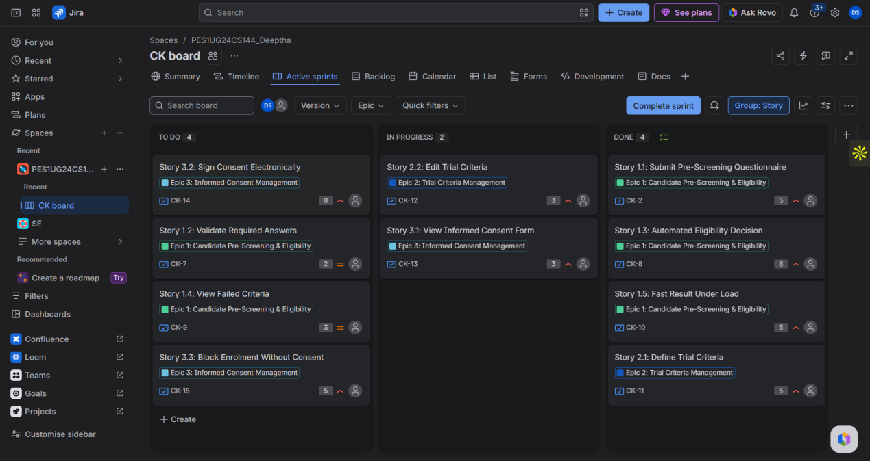

Sprint 1 completed

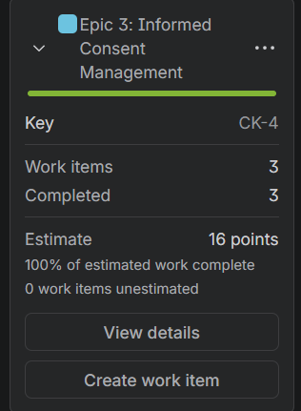
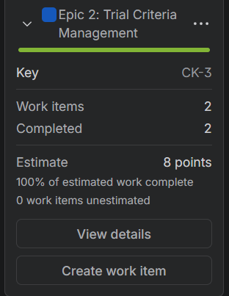
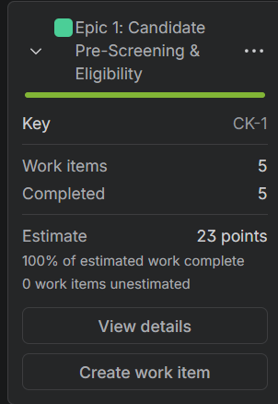

Sprint 2 with epic 4 and 5 done

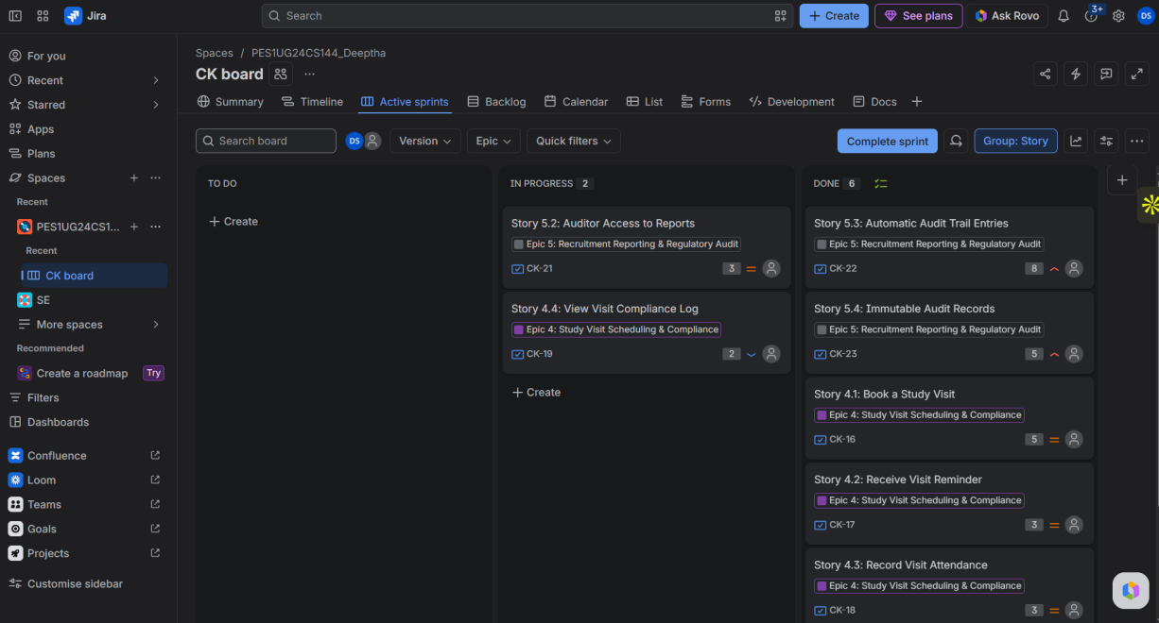

2 sprints completed

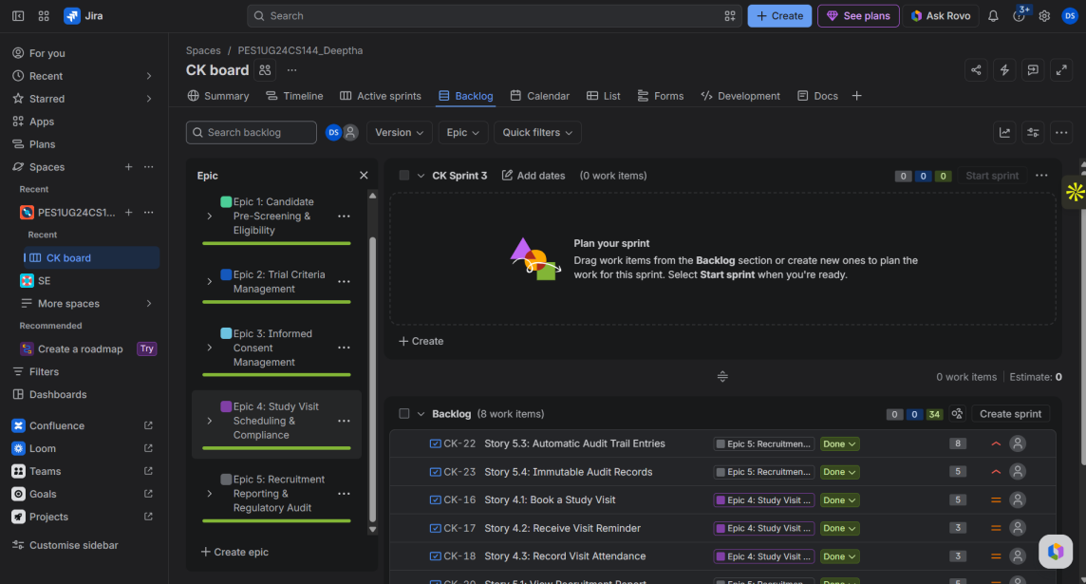

Burndown chart

Sprint 1
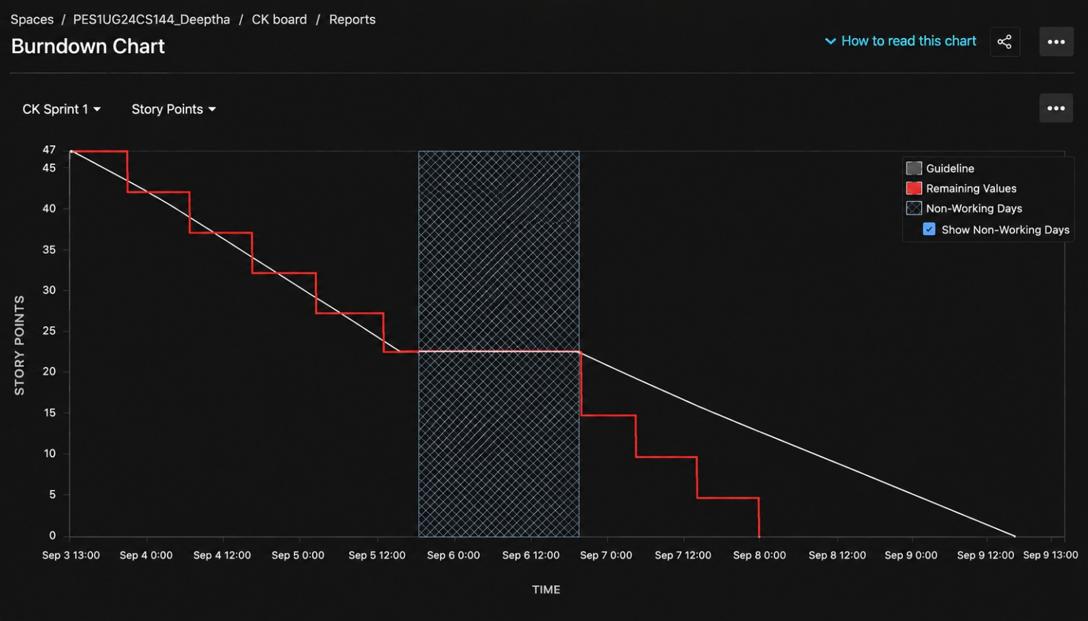

Sprint 2
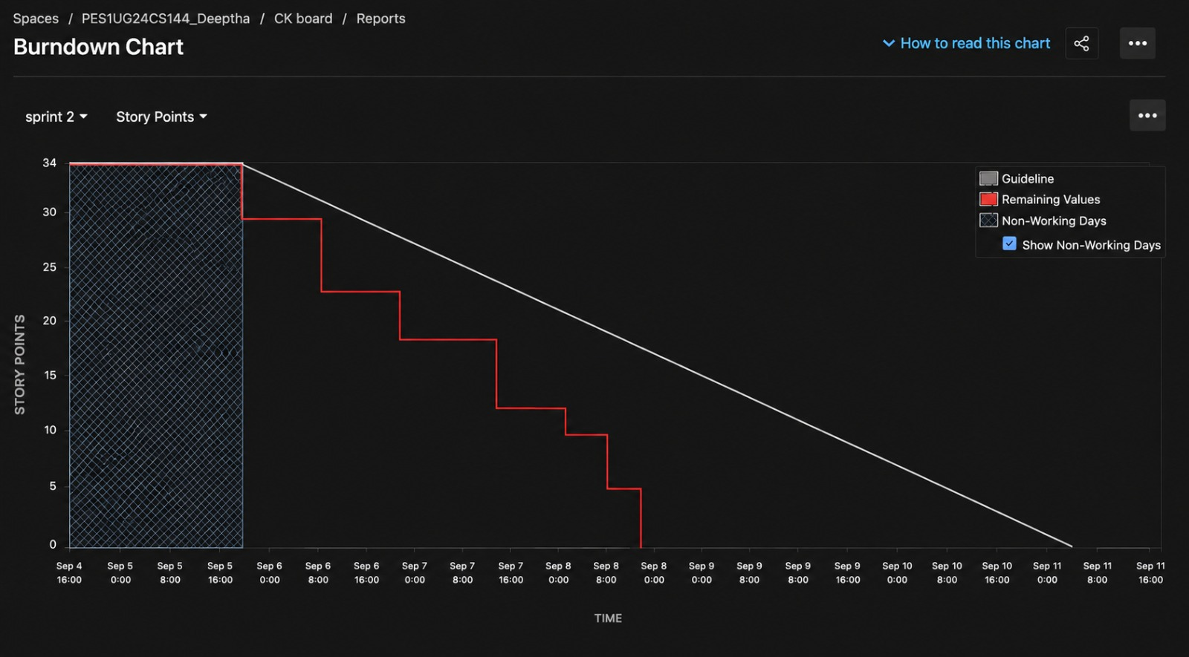

Reflection Questions:

1. Did your estimations reflect the actual effort?
Answer:
The estimations were reasonably consistent with the effort represented in the charts. Sprint 1 started with 47 story points and showed a gradual decrease through several smaller steps, indicating that stories with different levels of effort were completed at different times. The remaining work stayed around 22 points during the non-working period, after which it continued to decrease until reaching 0.
In Sprint 2, 34 story points were initially planned. The chart shows larger drops in remaining work, followed by several nearly equal decreases of about 5 story points before reaching zero. This suggests that some Sprint 2 stories had similar estimates and were completed in similar-sized chunks. Since this was a simulated sprint, the chart cannot prove the estimates matched real development effort, but the story-point distribution was useful for representing the relative complexity of the work.

2. Was your backlog well-prioritized?
Answer:
Yes. The prioritization can be seen in how the work was divided between the two sprints. Sprint 1 contained Epics 1, 2 and 3, totaling 47 points, covering candidate eligibility, trial criteria and informed consent. These are core features that are required before a candidate can properly proceed through the clinical trial process.
Sprint 2 contained Epics 4 and 5, totaling 34 points, covering visit scheduling, compliance and recruitment reporting/auditing. These features depend more on the basic trial and consent functionality being available first. Therefore, the backlog was prioritized according to both importance and dependency, rather than simply choosing features randomly.

3. How did your simulated sprint align with your plan?
Answer:
The work allocation aligned closely with the original plan. Sprint 1 began with 47 story points, corresponding to Epics 1, 2 and 3, while Sprint 2 began with 34 story points, corresponding to Epics 4 and 5. Both graphs show the remaining work eventually falling to 0 story points, indicating that all the planned stories were moved to completion.
The charts also show the effect of non-working days. In Sprint 1, the remaining work stays at approximately 22 story points during the shaded non-working period, rather than continuing to decrease. Sprint 2 similarly begins with a shaded non-working period before the remaining work starts decreasing. Thus, the work allocation followed the plan, although the actual sprint dates were not perfectly aligned with a normal sequential one-week Scrum schedule because this was a simulation.

4. What insights did the burndown chart give about your team's capacity?
Answer:
The two charts show different patterns of progress. Sprint 1 has a more gradual and detailed burndown, with the remaining story points decreasing through several smaller steps before reaching zero. This gives a clearer indication of progress throughout the sprint.
In comparison, Sprint 2 has a more coarse staircase pattern. After starting at 34 points, the remaining work decreases in larger steps, and toward the end there are several almost equal drops of around 5 points. This suggests that work was completed in larger batches rather than continuously throughout the sprint.
Although both sprints completed all their planned story points, the charts alone cannot be used to calculate our true team capacity because the sprint was simulated. To determine actual capacity or velocity, we would need several real sprints and compare the number of story points completed across them.

